Week 1 – The Post-Break Purge & Tech Turnover

Preface
I decided to start recording my weekly disposal habits not because I’m particularly obsessed with garbage, but because I started noticing a pattern of accumulation that was cramping my space—both physically in my room here at my Busch Apartment and mentally. As a student juggling CS projects and internships, my environment tends to reflect my stress levels: chaotic and cluttered. I wanted to force myself to confront the "churn" of my possessions.

Specifically, I want to track the lifecycle of the technology and gear I invest in. I spend a lot of time researching specs for things like laptops and watches, but I rarely analyze when and why I let them go. By documenting this, I hope to see if I’m buying things for the long haul or just cycling through upgrades for the dopamine hit. It’s an experiment in mindful consumption, or at least, mindful disposal.

Overview
This week was significantly heavier on the "value" scale than usual. Unlike previous weeks, when the bin was filled with takeout containers from King of Gyro or empty energy drink bottles, this week involved letting go of some serious hardware. It feels a bit like shedding a skin; I’m clearing out the remnants of last year to make space for new projects and a clearer head for the spring semester. The total monetary value of what left my possession this week is probably the highest it’s ever been, mostly due to a couple of tech sales.

I’ve categorized this week’s nine items into three distinct groups: The Tech Turnover, The Worn-Out Daily Drivers, and The Empty Vessels.

The Tech Turnover: This group consists of the ASUS ROG Zephyrus G14 Laptop, the Garmin Instinct 2X Solar Watch, and a stray USB-C Cable. These are the heavy hitters. The laptop and watch weren't "trash" in the traditional sense; they were functioning tools that I decided to move on from. The G14 was a beast for gaming and schoolwork, but I found myself needing an upgrade, since the laptop I got in high school was starting to show its age. I sold it to a friend who wanted to tinker with it. The Garmin was rugged and great for tracking my outdoor activities, but as a runner, I decided to upgrade to another Garmin watch that focused more heavily on running metrics. The cable? Just one of the tangled many that seem to reproduce in my drawer.

The Worn-Out Daily Drivers: This group includes the Black Leather Wallet, the Grey Sneakers, and the Broken Hanger. These items served their time honorably. The wallet has been in my pocket for years, shaping itself to my cards until the leather started to show its age. The sneakers (Tommy Hilfiger) have walked miles in the workplace I bought them for, and on campus, until there were holes at the heels. The hanger is a casualty of rushing to get ready for class; the velvet snapped under the weight of a heavy coat. These felt good to toss—they were items that had simply nothing left to give.

The Empty Vessels: Finally, we have the consumables: the Mankind Hero Cologne Bottle, the Frosted Lightbulb, and the Avatar: Fire and Ash Popcorn Bucket. These are the shells of experiences. The cologne was the go-to scent that I wore occasionally when going out since my Junior year of High School, when I bought it for Junior Prom, and hitting the empty spray was a sign to maybe try something new. The lightbulb flickered out while I was studying late, a small annoyance that felt symbolic. The popcorn bucket is a souvenir from seeing the new Avatar movie; it sat on my desk for a few weeks as a "collectible" before I admitted it was just taking up space.

Gallery
Asus ROG G14 Laptop
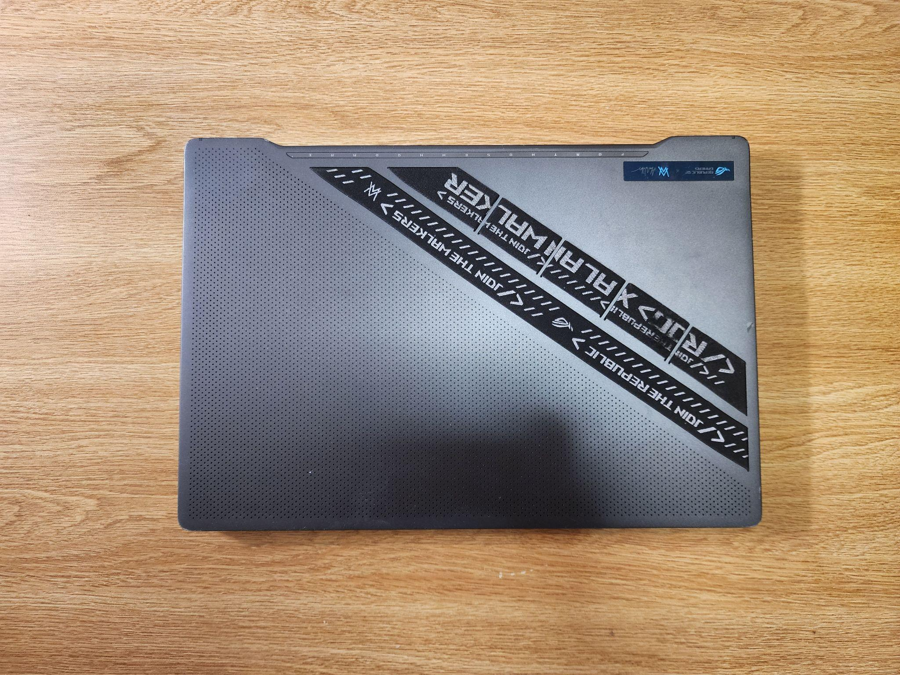

Garmin Instinct 2X Watch
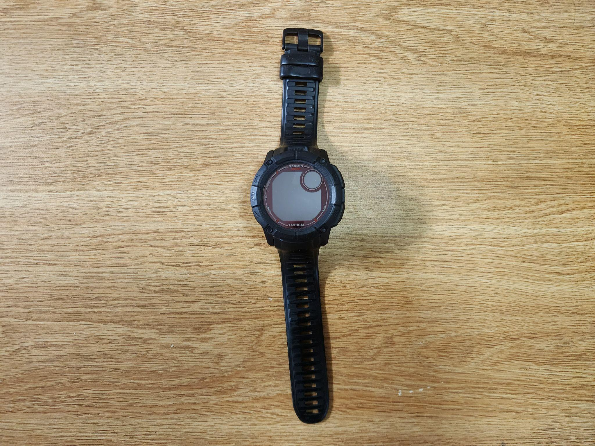

USB-C Cable
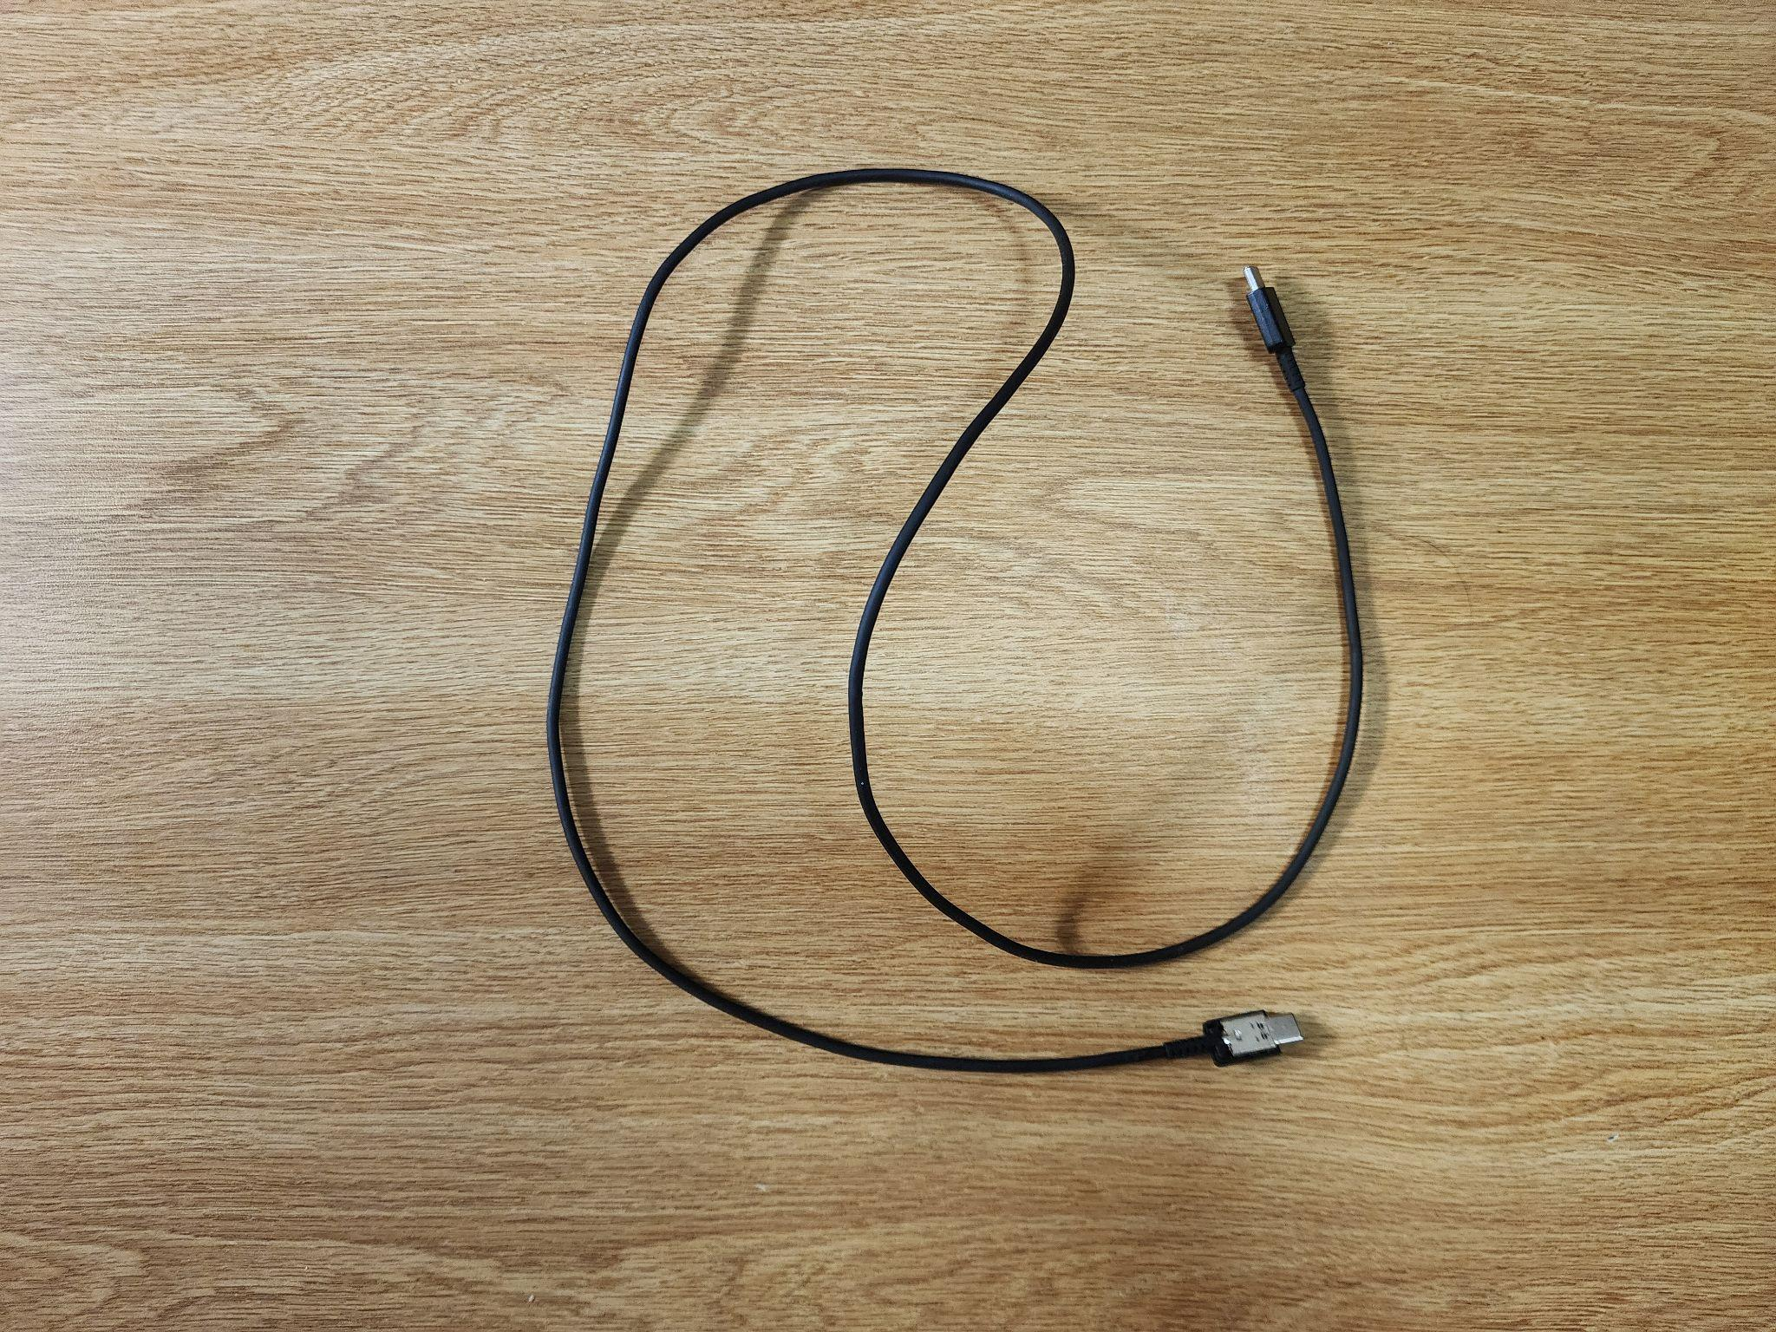

Leather Wallet
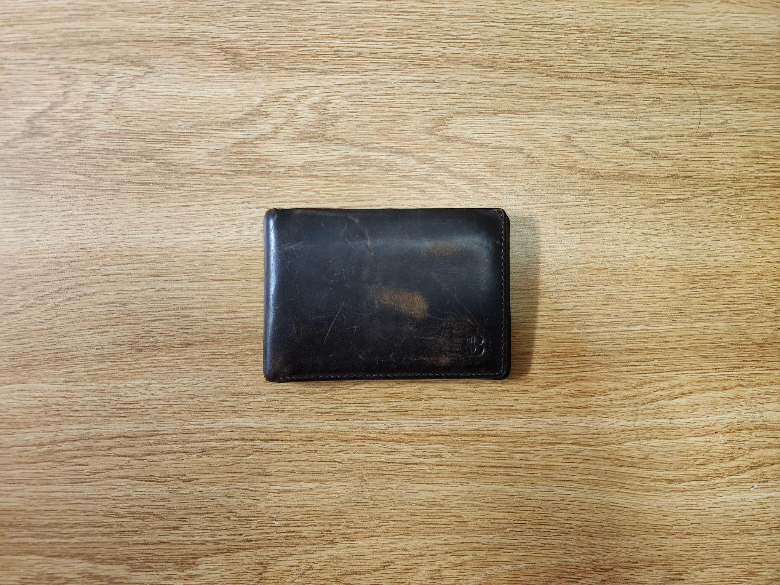

Grey Sneakers
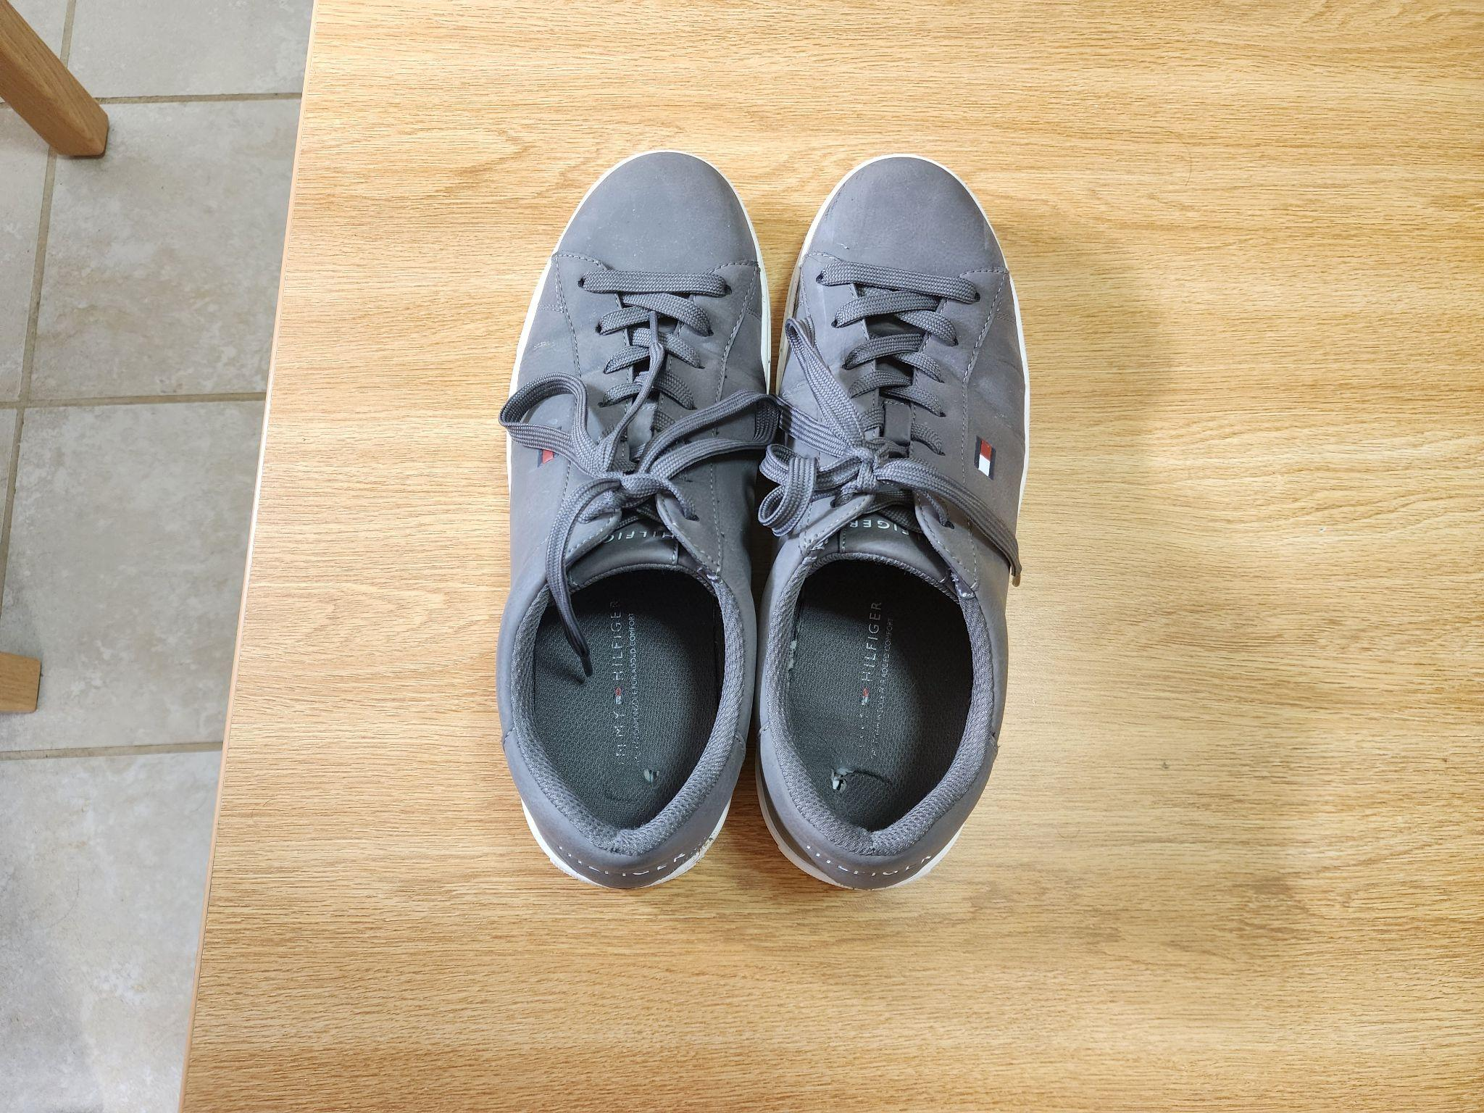

Broken Hanger
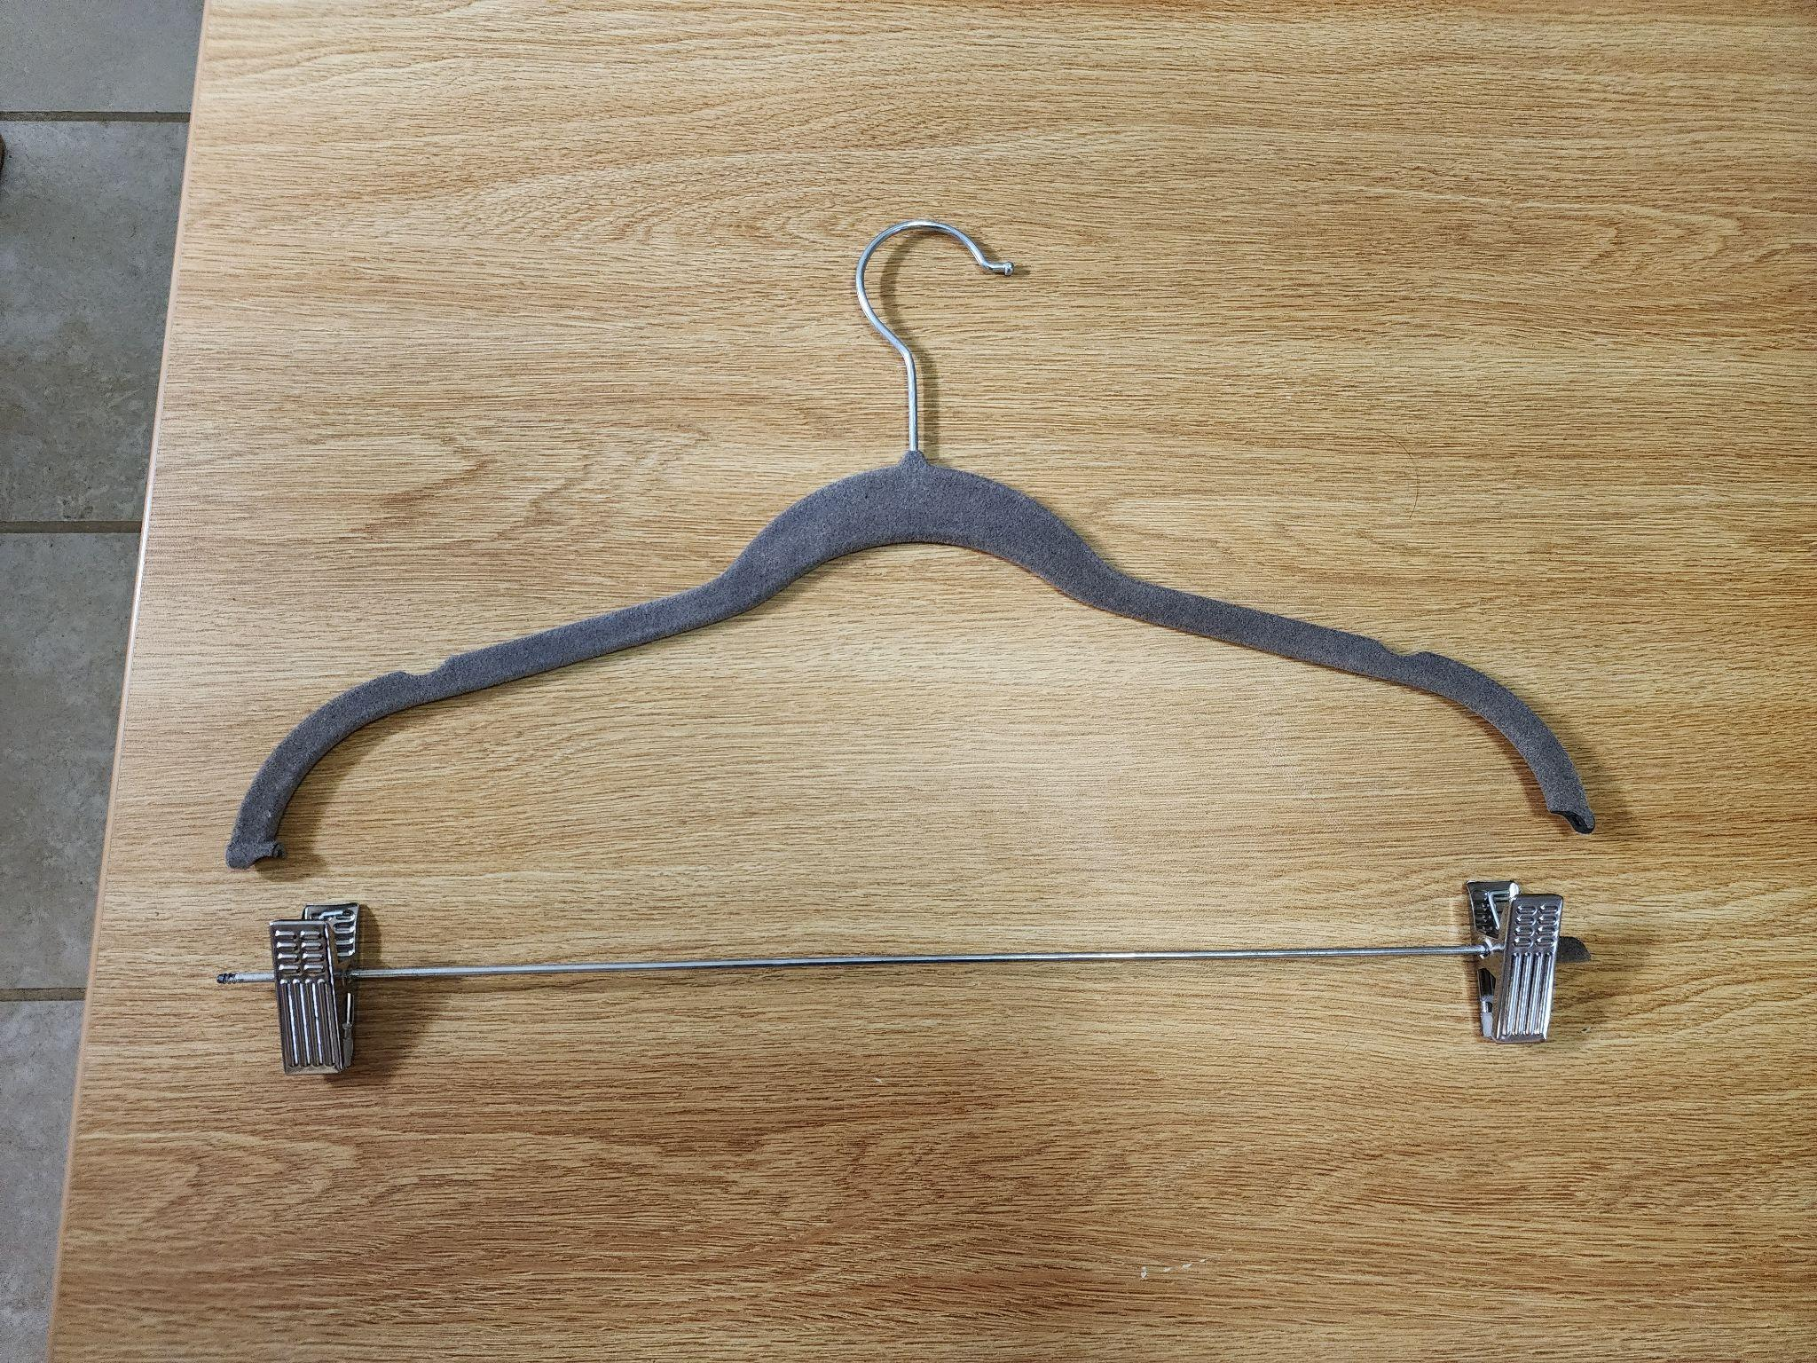

Mankind Hero Cologne
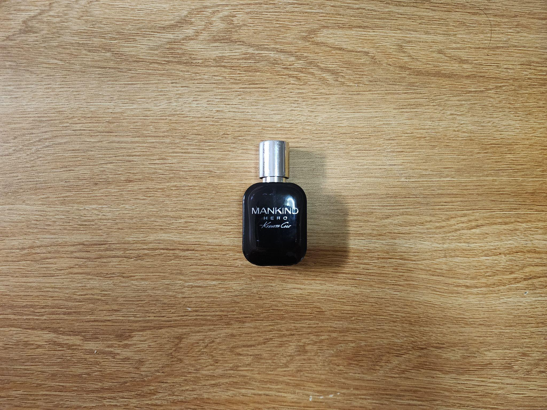

Frosted Lightbulb
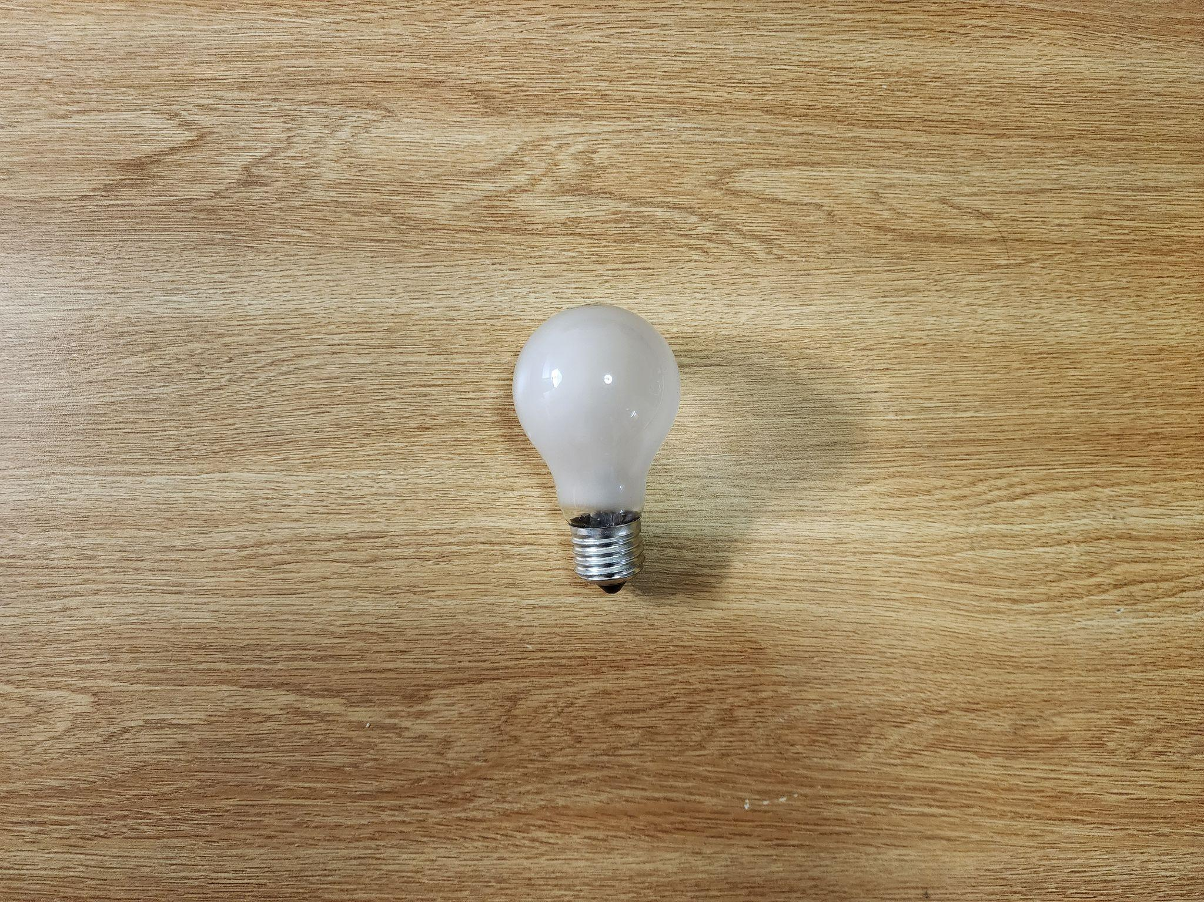

Avatar Popcorn Bucket
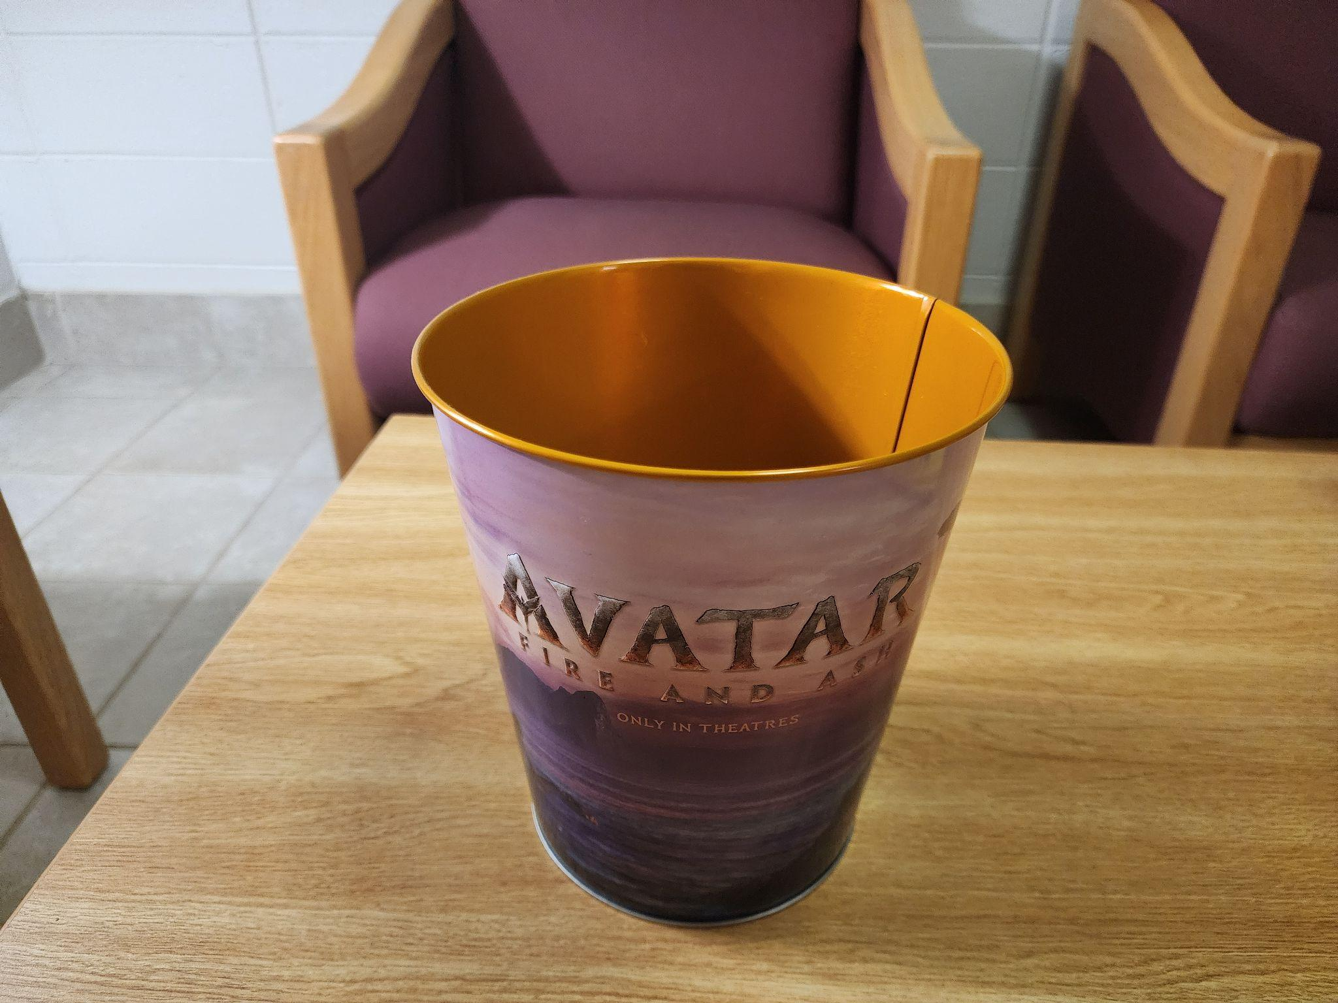

Item Data:

Item | Weight | Source | Location | Cost | Time Owned | Mode of Disposal | Condition
ASUS ROG G14 Laptop | ~3.6 lbs | Amazon | Desk | ~$1,400 | 3 Years | Sold | Good
Garmin Instinct 2X Watch | ~67g | Garmin Store | Wrist/Desk | ~$450 | 1 Year | Sold | Used
USB-C Cable | ~30g | Samsung Website | Drawer | ~$10 | 5 Years | Trash | Frayed
Leather Wallet | ~50g | Amazon | Pocket | ~$40 | 4 Years | Trash | Worn Out
Grey Sneakers | ~2 lbs | Macy's | Closet | ~$80 | 2 Years | Donated | Worn
Broken Hanger | ~40g | Target | Closet | ~$1 | 2 Years | Trash | Snapped
Mankind Hero Cologne | ~100g | Macy's | Desk Drawer | ~$70 | 1 Year | Recycled | Empty
Frosted Lightbulb | ~30g | Home Depot | Lamp | ~$3 | 3 Years | Trash | Burnt Out
Avatar Popcorn Bucket | ~150g | Rutgers Cinema | Desk | ~$15 | 1 Month | Recycled | Sticky

Coda
This week was a major purge. Converting unused tech back into cash feels like a win, and my room is starting to look less like a storage unit and more like a place to actually get work done. I’m riding this momentum into next week, where I plan to tackle the paper chaos accumulating on my bookshelves. Thanks for following along with the cleanup!

